Lab Assignment 4.1
Q1. Zero-Shot Prompting (Basic Lab Task)
Task:
Write a Python function that classifies a given text as Spam or Not Spam using zero-shot prompting.
Steps:
- Construct a prompt without any examples.
- Clearly specify the output labels.
- Display only the predicted label. Input:
"Congratulations! You have won a free lottery ticket." Expected Output:
Spam Prompt Instructed:
Classifier that categorizes a message is spam or not based on the predefined suspicious keywords present in the given dynamically typed input message.
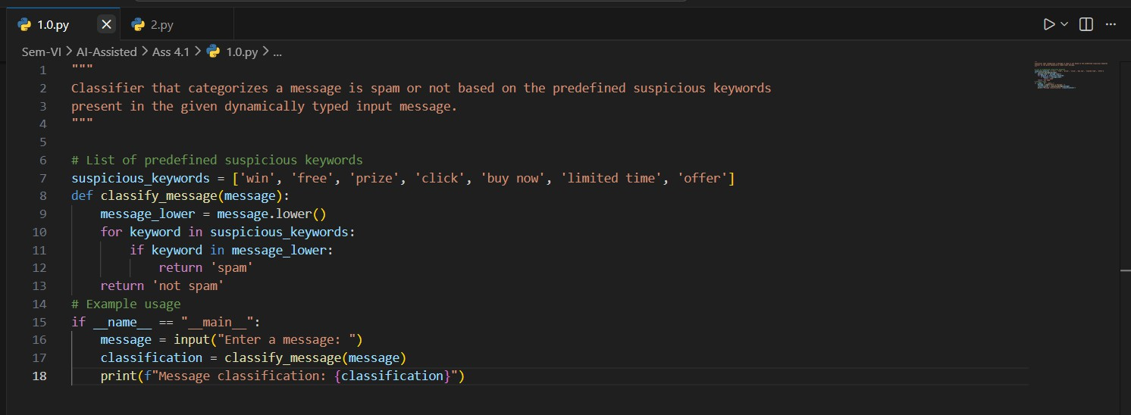
Output:
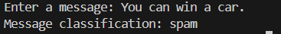

Q2. One-Shot Prompting (Emotion detection)
Task:
Write a Python program that detects the emotion of a sentence using one-shot prompting.
Emotions: [‘happy', 'sad', 'angry', 'excited', 'nervous', ’neutral’] Steps:
- Provide one labeled example inside the prompt.

- Take a sentence as input.
- Print the predicted emotion Prompt Instructed:
Python program that classifies the emotion expressed in a given sentence using a predefined set of emotions.
Emotions: ['happy', 'sad', 'angry', 'excited', 'nervous', 'neutral'] Example:
Sentence: "I am thrilled to announce my promotion!" Emotion: excited
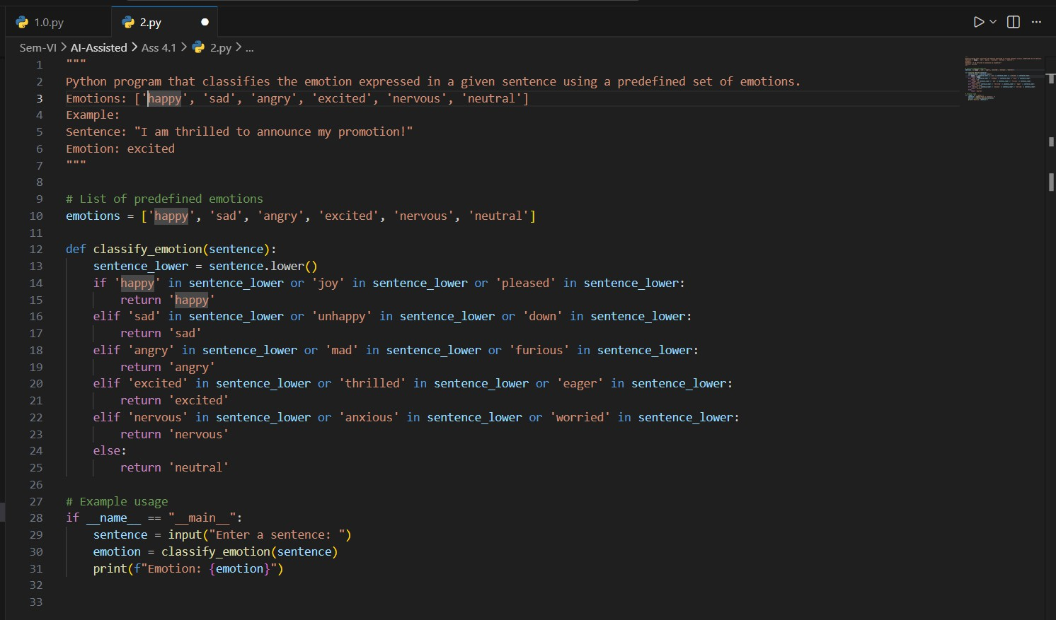
Input Sentence and Output:
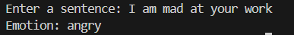

Q3. Few-Shot Prompting (Student Grading Based on Marks)
Task:
Write a Python program that predicts a student’s grade based on marks using few-shot prompting.
Grades:
  - ['A', 'B', 'C', 'D', 'F']
Grading Criteria (to be inferred from examples):
  - 90–100 → A
  - 80–89 → B
  - 70–79 → C

  - 60–69 → D
  - Below 60 → F Prompt Instructed:
Student grade calculator based on marks obtained Grades:
['A', 'B', 'C', 'D', 'F']
Grading Criteria (to be inferred from examples): 90-100 → A
80-89 → B
70-79 → C
60-69 → D
Below 60 → F Example: Input:
marks = 85 Output: Grade: B Input: marks = 72 Output: Grade: C Input: marks = 58 Output: Grade: F
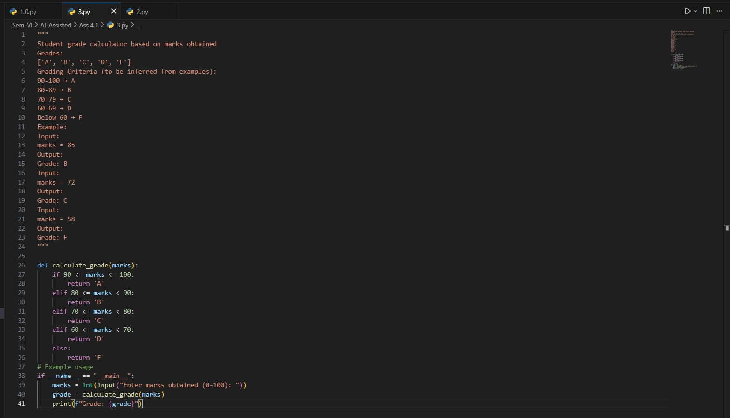

Q4. Multi-Shot Prompting (Indian Zodiac Sign Prediction using Month Name)
Task:
Write a Python program that predicts a person’s Indian Zodiac sign (Rashi) based on the month of birth (month name) using multi-shot prompting.
Indian Zodiac Order (Simplified Month-Based Model): The Indian Zodiac cycle starts in March with Mesha and follows this order:
March → Mesha April → Vrishabha May → Mithuna June → Karka July → Simha August → Kanya September → Tula
October → Vrischika November → Dhanu December → Makara January → Kumbha February → Meena
Predict the Indian zodiac sign using the given birth month name as input, Indian zodiac sign starts in March with Mesha and follows this order Examples of birth month and its zodiac sign:
Input followed by Output: March → Mesha
April → Vrishabha May → Mithuna June → Karka July → Simha August → Kanya September → Tula
October → Vrischika November → Dhanu December → Makara January → Kumbha February → Meena

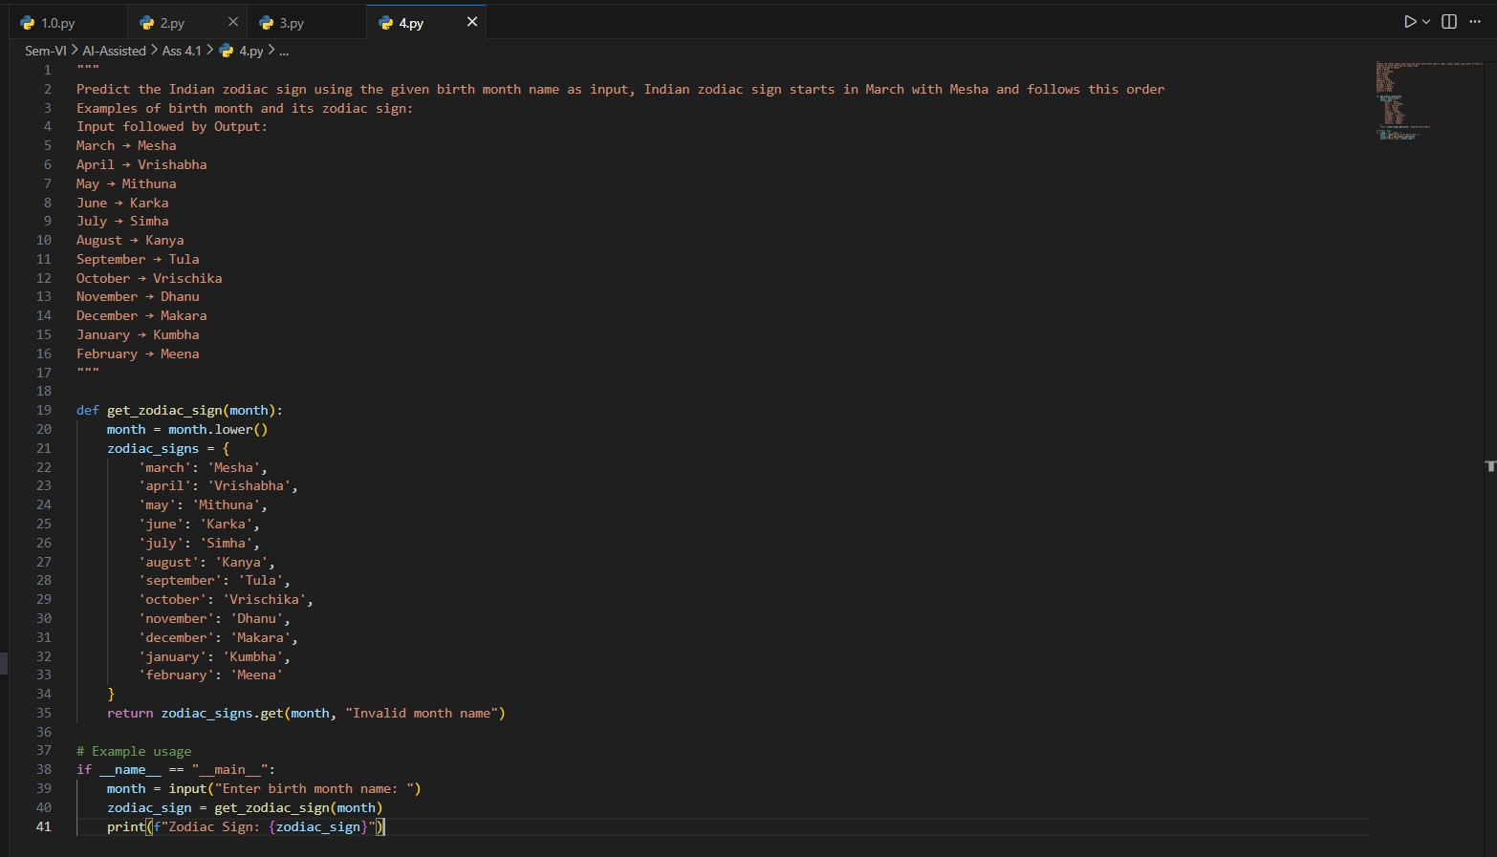

Q5. Result Analysis Based on Marks
Task:
Write a Python program that determines whether a student Passes or Fails based on marks using Chain-of-Thought (CoT) prompting.
Result Categories:
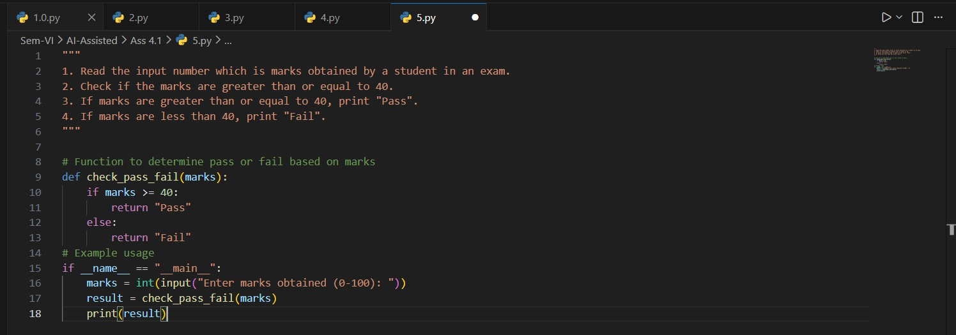
['Pass', 'Fail'] Prompt Instructed:

Q6 Voting Eligibility Check (Chain-of-Thought Prompting)
Task:
Write a Python program that determines whether a person is eligible to vote using Chain-of-Thought (CoT) prompting.

Prompt Instructed:
- Read the input number which is age of a person and store it in a variable.
- Check if the age is greater than or equal to 18.
- If age is greater than or equal to 18, print "Eligible to vote".
- If age is less than 18, print "Not eligible to vote".

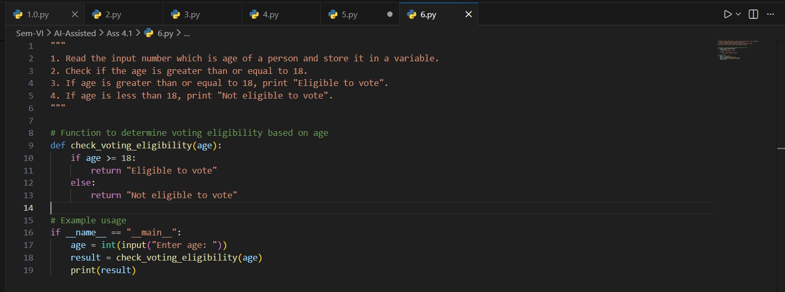

Q7 Prompt Chaining (String Processing – Palindrome Names)
Task:
Write a Python program that uses the prompt chaining technique to identify palindrome names from a list of student names.

Prompt Instructed:
Generate a list of names of students and store it in a variable.

Traverse the list while reversing each name from the list and store it in a list in another variable.

If the original name and reversed name are the same making sure they are not case sensitive, print "Palindrome" along with the name.

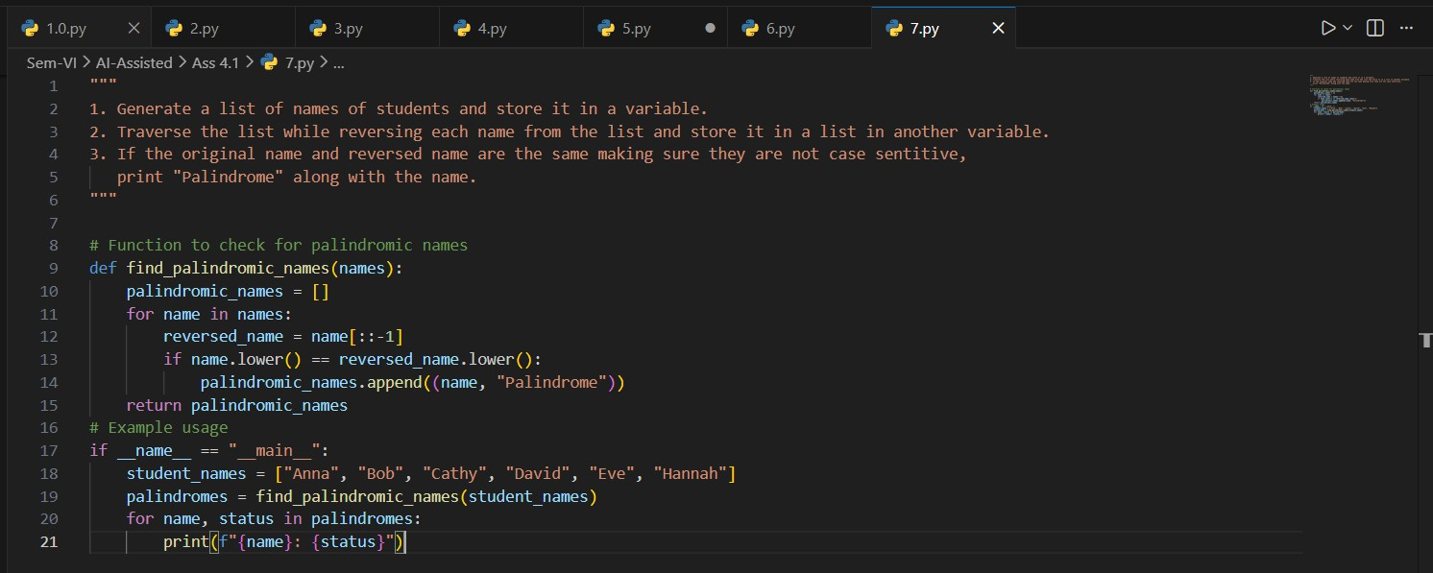

Q8 Prompt Chaining (String Processing – Word Length Analysis)
Task:
Write a Python program that uses prompt chaining to analyze a list of words. In the first prompt, generate a list of words. In the second prompt, traverse the list and calculate the length of each word. In the third prompt, use the output of the previous step to determine whether each word is Short (length less than 5) or Long (length greater than or equal to 5), and display the result for each word.

Prompt:
- Generate a list of words and store it in a variable.
- Traverse and calculate the length of each word in the list and store it in another list.
- Now traverse the list of lengths and print if the word is short (length
< 5), or long (length >= 5).

